LRDI

Ratio and proportion class 2

**https://www.facebook.com/events/2035820769966462**

Squares are net profit  
Triangles are sales

The fig. Below represents the sales and net profit in(cr) of IVP Ltd. For five years from 2010-11 to 2014-15.During this period,the sales increased from 100cr to 680cr.correspondingle the net profit increased from 2.5Cr to 12 Cr .  
Net Profit= total sales-total cost

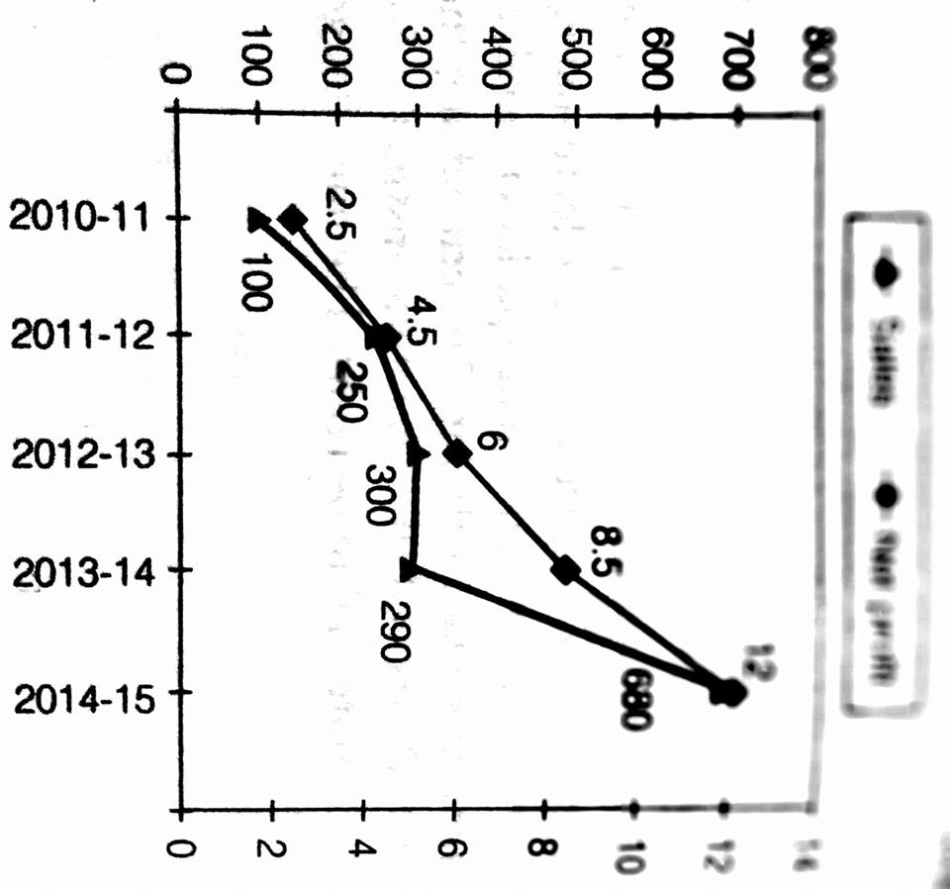

The highest %growth in sales,relative to the previous year occurred in   
A.2011-12   
B.2012-13  
C.2013-14  
D.20141-5

The highest % growth to the net profit,relative to the previous year occurred in?  
2014-15  
2013-14  
2012-13  
2011-12

Defining profitability as the ratio of net profit to sales,IVP Ltd. Recorded the highest profitability in  
2014-15  
2013-14   
2010-11  
2012-13

https://www.youtube.com/watch?v=7xdp4G6aAgs&feature=youtu.be

Chart 1 shows the distribution of twelve million tons of crude oil transported through different modes over aspecific period of time. Chart 2 shows the distribution of the cost of transporting this crude oil. The total cost was Rs.30 million.

1st graph= cost  
2nd graph=volume

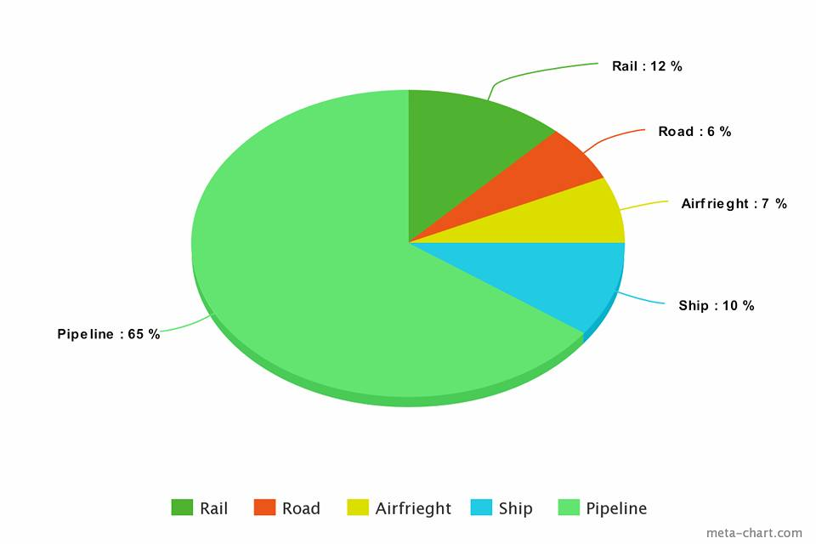

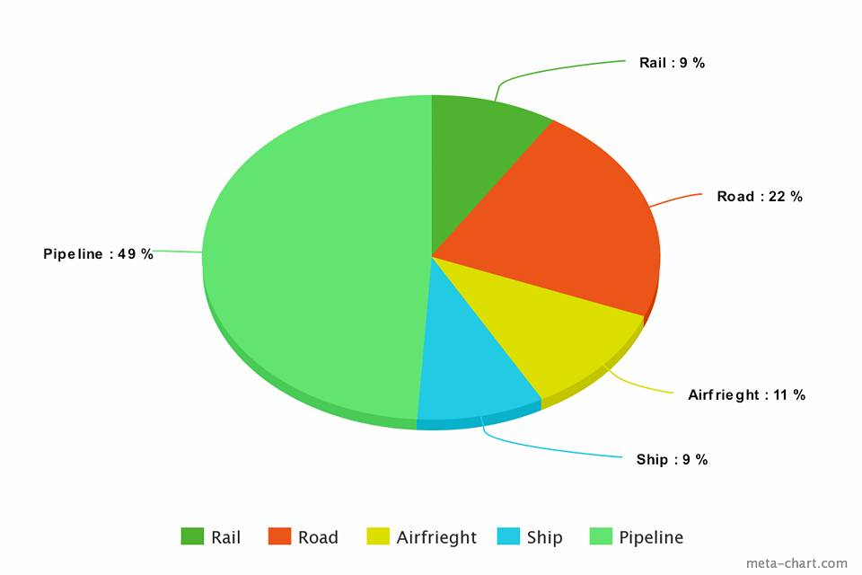

The cost in rupees per ton of oil moved by rail and road happens to be roughly  
(1) 3   
(2) 1.5   
(3) 4.5   
(4) 8

From the charts given, it appears that the cheapest mode of transport is  
(1) Road   
(2) Rail  
(3) Pipeline  
(4) Ship

If the costs per ton of transport by ship, air and road are represented by P, Q and R respectively, which of the following is true?  
(1) R > Q > P   
(2) P > R > Q   
(3) P > Q > R   
(4) R > P > Q

**https://www.youtube.com/watch?v=TyV-SOmBaNE&feature=youtu.be**

There are six companies, 1 through 6. All of these companies use six operations, A through F. The following  
graph shows the distribution of efforts put in by each company in these six operations.

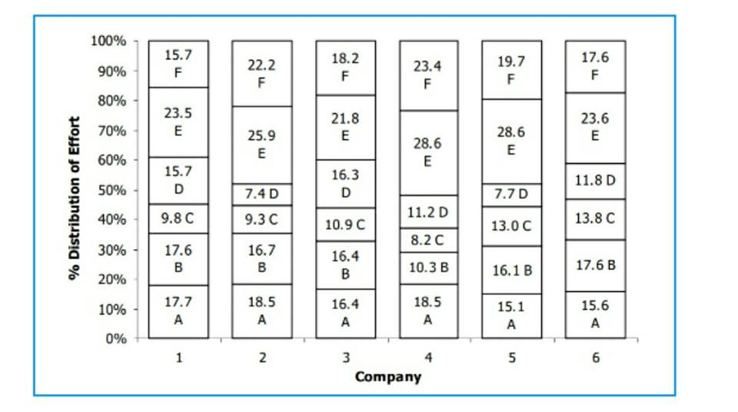

Suppose effort allocation is interchanged between operation B and C, then C and D, and then D and E. If companies are then  
ranked in ascending order of effort in E, what will be the rank of company 3?  
(1) 2   
(2) 3   
(3) 4  
(4) 5

A new technology is introduced in company 4 such that the total effort for operations B through F get evenly distributed among  
these. What is the change in the percentage of effort in operation E?  
(1) Reduction of 12.3   
(2) Increase of 12.3  
(3) Reduction of 5.6  
(4) Increase of 5.6

Suppose the companies find that they can remove operations B, C and D and redistribute the effort released equally among the  
remaining operations. Then, which operation will show the maximum across all companies and all operations?  
(1) Operation E in company 1   
(2) Operation E in Company 4  
(3) Operation F in company 5   
(4) Operation E in company 5

**https://www.youtube.com/watch?v=spxc1zTpWSg&feature=youtu.be**

Figure 1 shows the amount of work distribution, in man-hours, for a software between offshore and onsite  
activities. Figure 2 shows the estimated and actual work effort involved in the different offshore activities in  
the same company during the same period. [Note : Onsite refers to work performed at the customer's premise  
and offshore refers to work performed at the developer's premise].

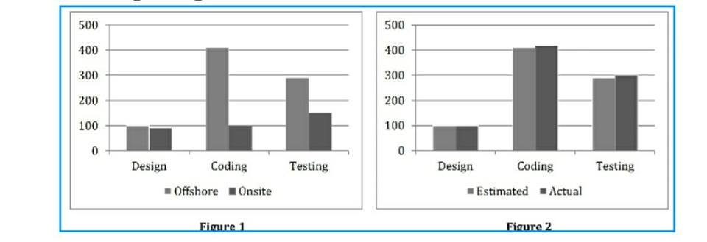

Which of the work requires as many man-hours as that spent in coding?  
(1) Offshore, design and coding   
(2) Offshore coding  
(3) Testing  
(4) Offshore, testing and coding

Roughly what percentage of the total work is carried out onsite?  
(1) 40 percent   
(2) 20 percent   
(3) 30 percent   
(4) 50 percent

The total effort in man-hours spent onsite is nearest to which of the following?  
(1) The sum of the estimated and actual effort for offshore design  
(2) The estimated man-hours of offshore coding  
(3) The actual man-hours of offshore testing A  
(4) Half of the man-hours of estimated offshore coding

the total working hours were 100, which of the following tasks will account for approximately 50 hours?  
(1) Coding   
(2) Design   
(3) Offshore testing  
(4) Offshore testing plus design

If 50 percent of the offshore work were to be carried out onsite, with the distribution of effort between the tasks remaining the  
same, the proportion of testing carried out offshore would be  
(1) 40 percent  
(2) 30 percent   
(3) 50 percent   
(4) 70 percent

If 50 percent of the offshore work were to be carried out onsite, with the distribution of effort between the tasks remaining the  
same, which of the following is true of all work carried out onsite?  
(1) The amount of coding done is greater than that of testing.   
(2) The amount of coding done onsite is less than that of design done onsite.  
(3) The amount of design carried out onsite is greater than that of testing.  
(4) The amount of testing carried out offshore is greater than that of total design.

**https://www.youtube.com/watch?v=MrIjQrDw3z0&feature=youtu.be**

Take your time and simplify your calculation.observation of graph is important rather than core calculation.  
Time taken should not be more than 15 mins  
  
The figures below present annual growth rate, expressed as the % change relative to the previous year, in four sectors of the economy of the Republic of Reposia during the 9 year period from 1990 to 1998. Assume that the index of production for each of the four sectors is set at 100 in 1989. Further, the four sectors manufacturing, mining and quarrying, electricity, and chemicals, respectively, constituted 20%. 15%. 10% and 15% of total industrial production in 1989.

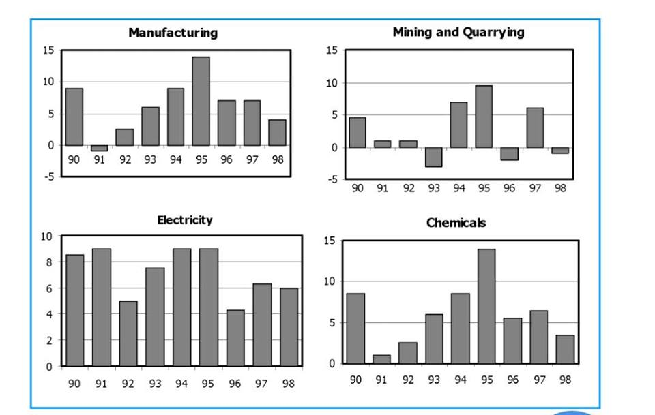

Which is the sector with the highest growth during the period 1989 and 1998?  
(1) Manufacturing   
(2) Mining and quarrying  
(3) Electricity   
(4) Chemicals

The overall growth rate in 1991 of the four sectors together is approximately  
(1) 10% (2) 1% (3) 2.5% (4) 1.5%

When was the highest level of production in the manufacturing sector achieved during the nine-year period 1990-1998?   
(1) 1998 (2) 1995  
(3) 1990 (4) Cannot be determined

When was the lowest level of production of the mining and quarrying sector achieved during the nine year period 1990-1998?   
(1) 1996 (2) 1993  
(3) 1990 (4) Cannot be determined

The percentage increase of production in the four sectors, namely, manufacturing, mining & quarrying, electricity and chemicals, taken together, in 1994, relative to 1989, is approximately  
(1) 25 (2) 20 (3) 50 (4) 40

It is known that the index of total industrial production in 1994 was 50 percent more that in 1989. Then, the percentage increase in production between 1989 and 1994 in sectors other than the four listed above is  
(1) 57.5 (2) 87.5 (3) 127.5 (4) 47.5

**https://www.youtube.com/watch?v=WIwAJS3oeG4&feature=youtu.be**

Goodnight!!

In a museum, six paintings were displayed on a wall from left to right. Each painting was of a different subject among Flower, Kitten, Ship, Apple, Fountain and Rock. Further, each painting was painted by a different artist among John, Vincent, Leonardo, Claude, Eduardo and Pablo. It is also known that   
1. the painting by Claude was to the immediate right of the painting of the Kitten, while the painting of the Flower was not painted by Pablo.

2. the painting by Eduardo was not adjacent to the painting by Leonardo, while the painting of a Rock was four places to the right of the painting by Vincent.

3. the painting of the Flower was to the right of the painting by John but was not to its immediate right.

4. the painting of the Apple and the painting by Pablo were at the two extreme ends.

5. the painting of the Ship was to the immediate left of the painting by Eduardo, while the painting of the Rock was not at any extreme end.

Who painted the painting of the Ship? a) Vincent b) John c) Leonardo d) Eduardo

Which of the following is true regarding the painting that is to the immediate right of the painting by Claude? a) The subject of the painting is a Flower. b) The subject of the painting is a Rock. c) It was painted by John. d) More than one of the above

Which of the following paintings did Eduardo paint? a) Painting of the Rock b) Painting of the Fountain c) Painting of the Flower d) Painting of the K

How many paintings are present between the painting by Leonardo and the painting of the Ship? a) 0 b) 1 c) 2 d) More than 2